Machine Learning Model Comparison Report: Interest Rate Prediction

Executive Summary
This comprehensive analysis evaluates five machine learning models for interest rate prediction using Q1 2024 mortgage data. XGBoost Regressor emerged as the clear winner with the lowest Mean Squared Error (0.2037) and highest R² Score (0.2958), explaining approximately 29.6% of the variance in interest rates.

Dataset Overview and Preprocessing
The analysis utilized a sampled dataset of 20,000 mortgage records, reduced to 17,223 records after removing missing values. The preprocessing pipeline involved extensive feature engineering, including the removal of 13 non-predictive columns, label encoding for binary variables, and one-hot encoding for categorical features, resulting in 24 final features for model training.
Key preprocessing steps included:
- Missing value treatment with mean imputation for interest rates
- Dropping 13.89% of records with missing Metropolitan Statistical Area data
- 80/20 train-test split (16,000 training, 4,000 testing records)

Model Performance Analysis
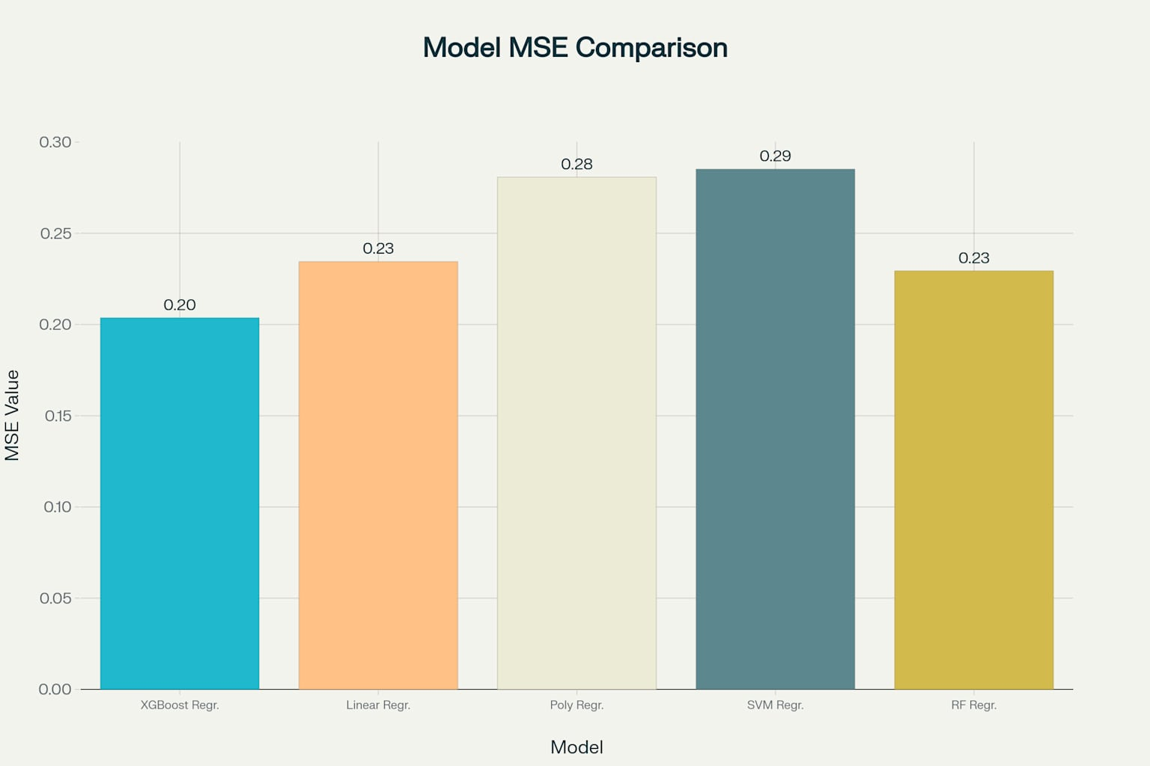
Mean Squared Error (MSE) comparison across different regression models
The performance comparison reveals significant differences between the five evaluated models:
Model | MSE | R² Score | RMSE
XGBoost Regressor | 0.2037 | 0.2958 | 0.4513
Random Forest Regressor | 0.2294 | 0.2067 | 0.4790
Linear Regressor | 0.2345 | 0.1892 | 0.4843
Polynomial Regressor | 0.2808 | 0.0293 | 0.5299
SVM Regressor | 0.2852 | 0.0138 | 0.5340

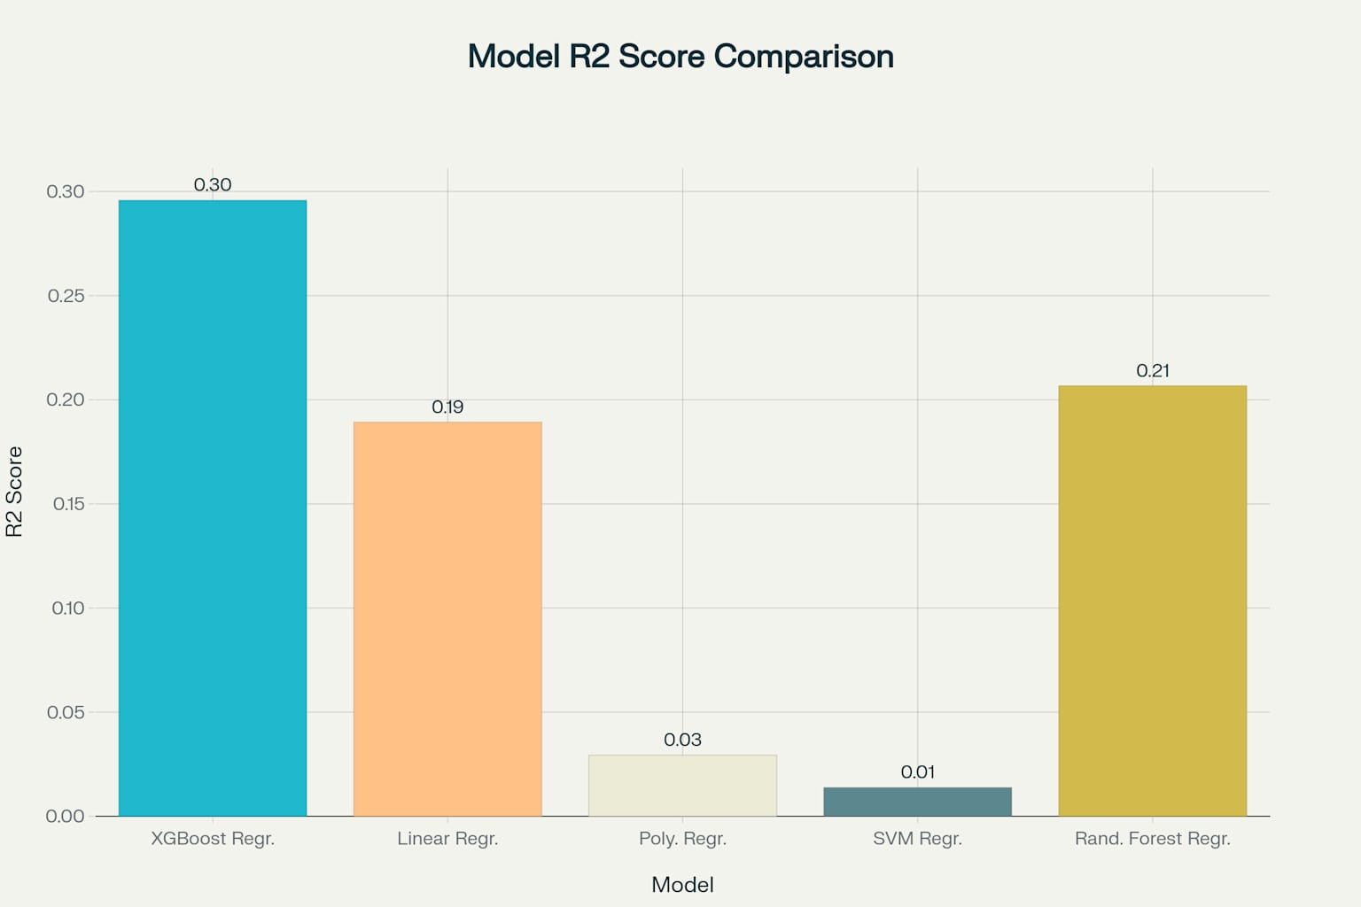R² Score comparison across different regression mode.

Key Performance Insights
XGBoost Regressor demonstrated superior performance through successful hyperparameter tuning via RandomizedSearchCV, with optimal parameters including subsample=0.8, n_estimators=200, max_depth=4, learning_rate=0.05, and colsample_bytree=0.7.

Random Forest Regressor secured second place but was limited by using only 10 estimators, suggesting potential for improvement with more trees.

Linear Regressor provided a solid baseline with moderate interpretability, while Polynomial and SVM Regressors showed poor performance, likely due to overfitting and unsuitable kernel selection respectively.

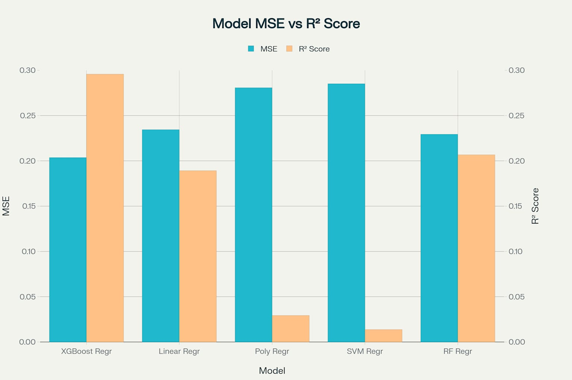
Comprehensive model performance comparison showing both MSE and R² Score

Business Implications
The 29.6% variance explanation indicates moderate predictive power, suggesting that significant factors influencing interest rates remain uncaptured in the current dataset. The RMSE of 0.45 percentage points provides a practical measure of prediction accuracy for business applications.
Current applications include preliminary interest rate estimation and initial screening, though the model requires enhancement for final pricing decisions.

Future Steps and Recommendations

1. Feature Engineering Enhancements
Critical additions should include economic indicators (federal funds rate, treasury yields, inflation), market conditions (housing price indices, unemployment rates), and enhanced borrower risk profiles. Advanced techniques like interaction terms, ratio features, and target encoding for high-cardinality variables will significantly improve model performance.

2. Model Architecture Improvements
Ensemble methods including stacking, blending, and voting regressors should be implemented. Advanced algorithms like neural networks, LightGBM, and CatBoost offer potential for better performance, while Bayesian methods can provide uncertainty quantification.

3. Data Quality and Scale
Scaling to the full dataset and incorporating external data sources (real-time market data, economic indicators) will substantially improve model reliability. Advanced preprocessing techniques including robust outlier detection and sophisticated imputation methods are essential.

4. Validation Framework
Time-series split validation respecting temporal order, walk-forward validation for deployment simulation, and comprehensive performance metrics including business-relevant measures (MAPE, directional accuracy) are crucial for production readiness.

5. Implementation Roadmap
Phase 1 : Foundation building with expanded datasets and robust validation
Phase 2 : Advanced feature engineering and algorithm implementation
Phase 3 : Production deployment with monitoring systems
Phase 4 : Continuous optimization and regulatory compliance

Success Targets
- 50-60% R² Score through advanced feature engineering and ensemble methods
- 25-30% RMSE reduction via improved data quality and optimization
- 90% prediction accuracy within 0.5% of actual rates
- <5% performance degradation over time through robust monitoring

Technology Stack
Development: Python ecosystem (scikit-learn, XGBoost, pandas), cloud platforms (AWS SageMaker, Google AI Platform), and comprehensive version control.
Production: REST APIs for serving, MLflow for monitoring, Apache Airflow for data pipelines, and time-series databases for storage.

Conclusion
The current XGBoost model establishes a solid foundation with 29.6% variance explanation, but substantial improvement opportunities exist. Systematic implementation of the recommended enhancements can realistically achieve 50-60% R² scores while maintaining interpretability and regulatory compliance. The key lies in balancing model complexity with business objectives, ensuring robust validation practices, and maintaining focus on practical deployment requirements.

